**Plickers – Quick Guide**

|  |  |
| --- | --- |
| *Checklist before using pickers with students:*   * Create an account at [www.plickers.com](http://www.plickers.com) * Create classes and enter your students. * Print out cards for your students 🡪 Class set or individual cards. * Download the Plickers App on your smart phone or tablet. |  |

*Tips:*

* It is not necessary to enter the exact question into plickers. Instead you can enter “Q1” and then project the question on your projector/smartboard.
* You can create questions on your phone/tablet
  + Pick a class period. Select **Queue**. Select **Create.**
  + The downside is that you cannot easily copy the question to other classes. (It is easy to do this in the web version).

*Creating an account:*



|  |  |
| --- | --- |
|  |  |

Before:



After:

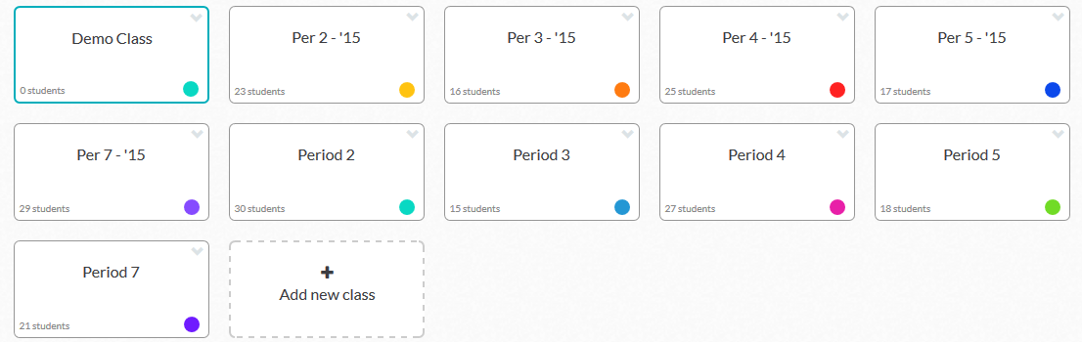

Reports from the website:

